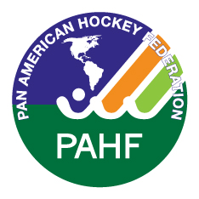

##### APPENDIX 5

# **PAHF CONGRESS**

# **Lancaster, PA – USA – 10th August 2017**

# **NOMINATION TO PAHF COMMITTEES**

# **APPOINTMENTS / COMPETITIONS / UMPIRING**

NOMINEE INFORMATION

|  |  |  |
| --- | --- | --- |
| Name: |  | |
| Nomination for (name of committee): | | |
| Address: | | |
| Tel: | | Fax: |
| E-mail: | | Mobile: |
| Position in the NA: | | |
| Date of Birth: | | |

**EXPERIENCE IN HOCKEY/SPORTS**

**Present or past activities in sports:**

|  |
| --- |
|  |
|  |
|  |

**Activities at National level (NA/ NOC)**

|  |
| --- |
|  |
|  |
|  |

**Activities at International level (CF, FIH, IOC, Other)**

|  |
| --- |
|  |
|  |
|  |

**Present or past activities in profession:**

|  |
| --- |
|  |
|  |
|  |

**Any other achievements (Awards, Merits etc.)**

|  |
| --- |
|  |
|  |
|  |
|  |
|  |
|  |

National Association:

Signature of President or Secretary:

Name:

Position:

Date:

This form must be returned to the PAHF no later than **31st May 2017** by email to

[lauramac@panamhockey.org](mailto:lauramac@panamhockey.org) and [derek.sandison@panamhockey.org](mailto:Julio.Neves@panamhockey.org)